WEST CLANDON PARISH COUNCIL
Chairman: Terence Patrick, Stoney Royd, Woodstock, West Clandon Surrey GU4 7UJ
Tel. 01483 222 534

Clerk: Rebecca Pluthero, Tudor Lodge, Clandon Road, West Clandon. GU4 7UU
clerk@westclandon.org.uk

Minutes of the Meeting held on Wednesday 10 February at 8.00pm via Zoom Call

Present:

Parish Councillors: | Terence Patrick (Chairman) (“TP”), Jonathan Murphy (Vice-Chairman) (“JM”), Chris Dean (“CD”), Ann Dickinson (“AD”), Paul Edwards (“PE”), Eric Palmer (“EP”) and Jenny Wicks (“JW”), Stephen Meredith (“SM”)
Surrey County Councilor: | Keith Taylor (“KT”)
Guildford Borough Councilor:
In attendance: | May Ann Civil

Presentation by May Ann Civil on Gigabit Broadband Government Voucher Scheme (Voucher Scheme)
May-Ann Sybil informed the Council that a number of West Clandon residents had got together to apply for the Voucher Scheme. The purpose of the presentation was to inform the council of the benefits of the scheme and to request the PC’s assistance in publicizing the scheme to meet the new deadline, established by Open Reach, of 19 February.

The offer from Open Reach to install fibre broadband, free of charge to every home in West Clandon, is dependent on 500 addresses within West Clandon signing up to the voucher Scheme by 19 February.

John Stone reminded the PC that the neighbourhood plan survey revealed that faster broadband was one of the top concerns of residents.

The PC offered their full support.

CD proposed and JW seconded the PC provide £500 to facilitate a leaflet drop to all West Clandon Residents.

It was suggested emails should be sent out on the Clandon Neighbourhood email group. May Ann Civil to provide the text for this.

John Stone reminded the PC there is a database of contacts from the Neighbourhood Plan survey who expressed an interest in receiving future information. This is held on the old laptop. Terence will follow up with the Parish Clerk.

TP to put May Ann in touch with Mark Bridger so that this can be publicized on the village website and a unique ‘broadband@’ email address set up.

The PC thanked May Ann for all the work she has done.
~ 2 ~

Following May Ann’s presentation, the Parish Council then proceeded with its normal meeting..

- Apologies for absence
Rebecca Pluthero
Catherine Ann Young
Chris Barrass and Catherine Ann Young
Tim Anderson

- 20/99 Declarations of interest
Terence Patrick declared that he was an Honorary Alderman in the Borough of Guildford and member of the Village Hall Management Committee. Chris Dean is a member of the Village Hall Management Committee. Jonathan Murphy is an Associate Governor of Clandon School and a Trustee of the Friends of West Clandon Church. Eric Palmer is the Chairman of the East and West Clandon Residents Association (EWCRA).
Eric Palmer declared an interest in a variation to planning application to his house, Bruce Cottage.
- Confirmation of the Minutes of the meeting held on January 13th 2021

- The record of attendees was incorrect. Tim Anderson and Chris Barrass did not attend.

- SM requested it be noted the wording in the Finance Matters section was incorrect and should read, “the financial transactions were approved by the council”.

- John Stone expressed concern that as he is no longer a PCor he could not read the minutes and asked if he had been quoted correctly. TP read the relevant section of the minutes out loud and John Stone said he was happy with the wording.

The Minutes of the aforementioned meeting were agreed subject to the above adjustments.

- Matters arising from the meeting on January 13th 2021
- TP informed the meeting that the hosting of the website had now moved to TSO hosting.
However, Chris Harlow has not released the PC email contact data.
Mark Bridger is chasing him to this.
Mark Bridger has already done the ground work to set up the new PC email addresses and as soon as Chris Harlow transfers them he, Mark, will be in touch with Parish Councillors via the Chairman..
- Planning Matters

JM reported on the Planning Applications received since the January 13th meeting.

The PC agreed not to comment on any of the new applications.

~ 3 ~

- 20/103 Financial Matters and Approvals

SM proposed budget for 2021/2022 be accepted and Parish Council agreed.

Grants of £1,000 each to Clandon School and The Friends of West Clandon Church CIO to be put towards specific projects specified by those organisations were approved and the Clerk was instructed to pay these amounts to them on receipt of details of what the grants were to be used for.

The Council was informed the British Legion was in no need of immediate support. SM left the door open for them to come back should the situation change.

Chris Dean was asked to contact John Vickers to submit a long term plan of works that need doing to the Village Hall for the Parish Council’s consideration.

SM informed the Council the £360 grant has arrived for new windows in the Village Hall. CD to ask John Vickers to supply invoices to enable the Parish Council to pay the money out.

All Parish Councillors confirmed that they are satisfied with the financial report from SM.

- 20/105 Local Plan update

CD confirmed that there were no updates pertaining to the Local Plan but did inform the Council of the following:

- CD received a request from Ripley PC for West Clandon response to the proposed slip roads at Ockham and Ripley. CD sent the letter previously approved to the Wisley planners.

- CD informed the Council the Highways Agency has stated it is not against slip roads at Ockham but they are nothing to do with their M25 Junction 10 scheme.

- Ripley is gearing up to lobby for slip roads at Ockham because the mitigation offered to counter the increased traffic flow through Ripley is insufficient.

- The Minister will not make decision on the M25 Junction 10 scheme until May so this will probably delay Wisley planning application.

- Neighborhood Plan update

The Plan has now been sent for validation checks.

The results of the validation checks will come to the Parish Clerk at the old PC email address and TP agreed to highlight this to Rebecca and to Mark Bridger.

~ 4 ~

- Recreation Ground, Playground and Car Park

EP informed the Council the tennis court was vandalized in January - a 6ft gash was cut into boundary netting. EP has now repaired the gash and removed the tennis net.

EP has fine-tuned the annual contract with Nurture for upkeep of recreation ground, car park, playground and dragon. This has resulted in a 10% reduction in the fee which will then free up some money for extra cuts of the Recreation Ground grass if needed. EP explained that upkeep of the Dragon (three strims for during the year) in the contract. EP announced Nurture will also look after the hedge at the back of the tennis court which the West Clandon Tennis Club will pay for.

- Footpaths

FP 67: a resident was concerned about a dangerous tree which PE reported to the Surrey Council. The council inspected the tree within 48 hours and decided no immediate work was required but the tree should be monitored.

On the same footpath, in the field by the prison, the staggered barrier has been pulled down. PE has reported this to SCC and if they do not respond quickly, PE will try to remove the barrier himself.

At the point where FP 568 crosses FP 66, there is a kissing gate. The ditches on both sides of this kissing gate need clearing. PE reported that both John Vickers and Martin Grant have promised to do the necessary work.

FP 68 has seen more fly tipping, but the SCC removed it very quickly. PE informed the PC that East Clandon Parish is talking to Savilles, land agents for Rocco Forte, to try to come up with a long term solution.

John Stone reported that the ditches near the bollards at end of Green Lane are in state of disrepair and as a result, water flows onto the bridleway, eroding the surface that Surrey County Council put in a few years ago. PE will talk to his opposite number on East Clandon PC.

- A247 Matters

Keith Taylor confirmed the bollard has been replaced – it is just hidden by current road works.

- Council Correspondence sent and received

TP informed the council:

Query over Covid costs and precepts

Resident complaining about Gigabit broadband. Clerk will reply.

Lots of emails from one resident. Rebecca will write to her saying that the Neighbourhood Watch group has not been disbanded. Rebecca also informed her that we are not responsible for enforcing covid regulations and that Parish Councillors were all volunteers.

~ 5 ~

It was said that a Police PCSO used to attend our meetings in the past and suggested that efforts should be made to invite a Police representative to attend in future.

TP said that he would follow this up.

Keith said other Parish Councils were also asking the same question but the police were saying that they do not have the resources to do so..

Date of next PC Meeting – Wednesday, March 10th 2021 at 8pm.

- Any Other Business

JW informed the Parish Council of an email from Catherine Ann Young about the Climate Change committee she has set up at the Borough Council. Catherine was asking whether we had any volunteers for it.
It was agreed JW should reply that the Parish Council is interested in joining these discussions. but we did not discuss.
PE said he’d be interested partly because it links up to something he is doing with the County Council about planting trees.

KT said he would resend the email on the Climate Change Committee to Clerk and to the Chairman.

- Date of next PC Meeting

This would be on Wednesday, March 10th 2021 at 8pm by zoom.

There being no further business, The Chairman closed the meeting at 22.02

__________________________________________

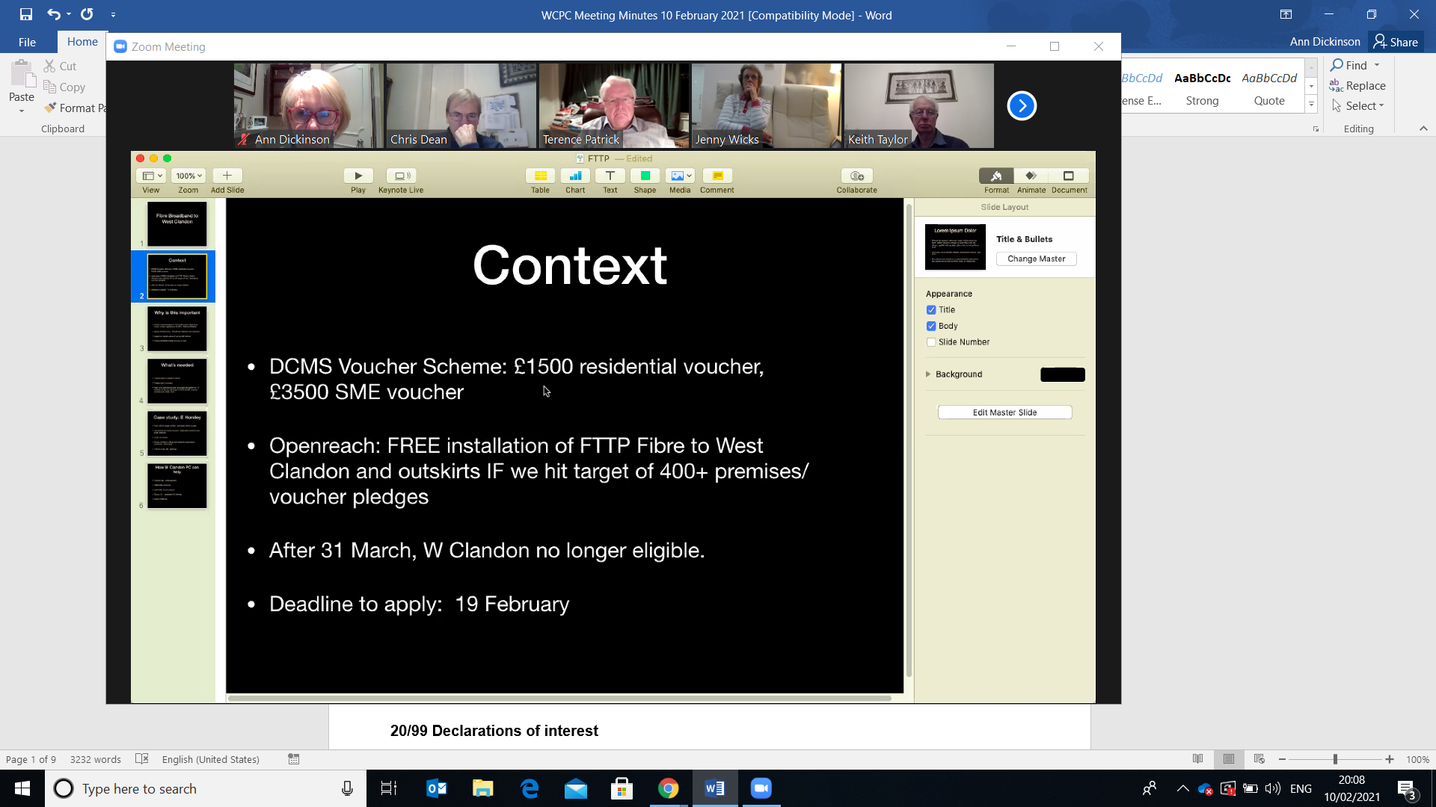
CORRESPONDENCE RECEIVED to be reported at the Meeting to be held on Wednesday 14th October 2020.

Correspondence Sent:

Correspondence Received:

